

AWS Architecture
Detailed Design Document


Prepared for: Najhum Technologies
Prepared by: Ashu Rana on the behalf of Rackspace
Table of Contents
1 Document Control 3
1.1 Revision History 3
2 Introduction 4
3 Architecture 5
3.1 High Level Design 5
3.1.1 Traffic Flow 6
Low Level Design 6
4 Naming convention 7
4.1 Compute 7
4.1.1 Elastic Compute Cloud (EC2) 7
4.1.2 Application Load Balancer 7
4.2 Networking 7
4.2.1 Virtual Private Cloud (VPC) 7
4.3 Storage 7
4.3.1 Simple Storage Service (S3) 7
4.4 Default Naming 7
5 Networking 8
5.1 VPC 8
5.2 Private Subnet 8
5.3 Internet Gateway 8
5.4 Public Subnet 9
5.5 Availability zones 9
5.6 Security Groups 9
5.7 NACL 10
5.8 VPC Details 10
5.9 Subnets Details 10
6 Elastic Compute Cloud (Ec2) 11
7 Application Load Balancer (ALB) 12
8 Simple Storage Service (s3) 12
9 Tagging Strategy 13
10 Logging and Monitoring 14
10.1 Introduction 14
10.2 VPC Flow Logs 14
10.3 AWS CloudTrail 14
10.4 AWS CloudWatch 14
11 Identity & Access Management 15
12 Exclusions 15

Document Control

Revision History
Version | Date | Author | Comments
0.1 | 31st May 2024 | Ashu Rana | Architecture and Implementation details

Introduction
Najhum Technologies is undertaking a Proof-of-Concept (PoC) to explore the capabilities and advantages of Amazon Web Services (AWS) for deploying and managing Internet of Things (IoT) solutions. This initiative aims to leverage AWS’s robust cloud infrastructure to understand how well it supports IoT workloads, offering insights into its performance under real-world conditions. Specifically, this PoC will focus on hosting a single application server within the AWS Cloud supported by a data layer. This will provide Najhum Technologies with a comprehensive understanding of the AWS platform’s suitability for their IoT projects, identifying any potential limitations before proceeding with a full-scale deployment.
This phase facilitates hands-on skill development and exposure for Najhum Technologies team, thereby validating the efficacy of the new platforms through tangible proof of value, ultimately informing strategic outcomes.
Additionally, this document delineates the architectural and design processes relevant to the AWS architecture, encompassing various parameters essential to consider when deploying resources on public cloud services.

The main requirements and design decisions for the project have been generated from the high-level proposals in the following table:

Reference | Requirement
D001 | AWS's primary region will be Middle East (UAE) – me-central-1
D002 | There will be single Environment (Prod)
D003 | AWS account is created, and access to the account is provided by the customer.
D004 | AWS CloudTrail, CloudWatch, s3, IAM, Certificate Manager will be used to support the provisioning.
D005 | Application will be deployed on Ec2 instances exposed through Application Load Balancer.
D006 | MySQL and PostgreSQL DB will be deployed on ec2 instances by the customer developers.
D007 | Dev/Test server will be deployed in same account.
The following are Risk Assumption issues and dependencies.
Reference | Requirement
RI01 | Decision on AWS s3 bucket, firewall rules and related application details is pending on the customer and will be decided at the application deployment phase.
RI02 | ALB configuration will be confirmed at the application deployment phase.

Architecture

High Level Design
Below diagram shows the AWS Architecture estate for Najhum technologies.

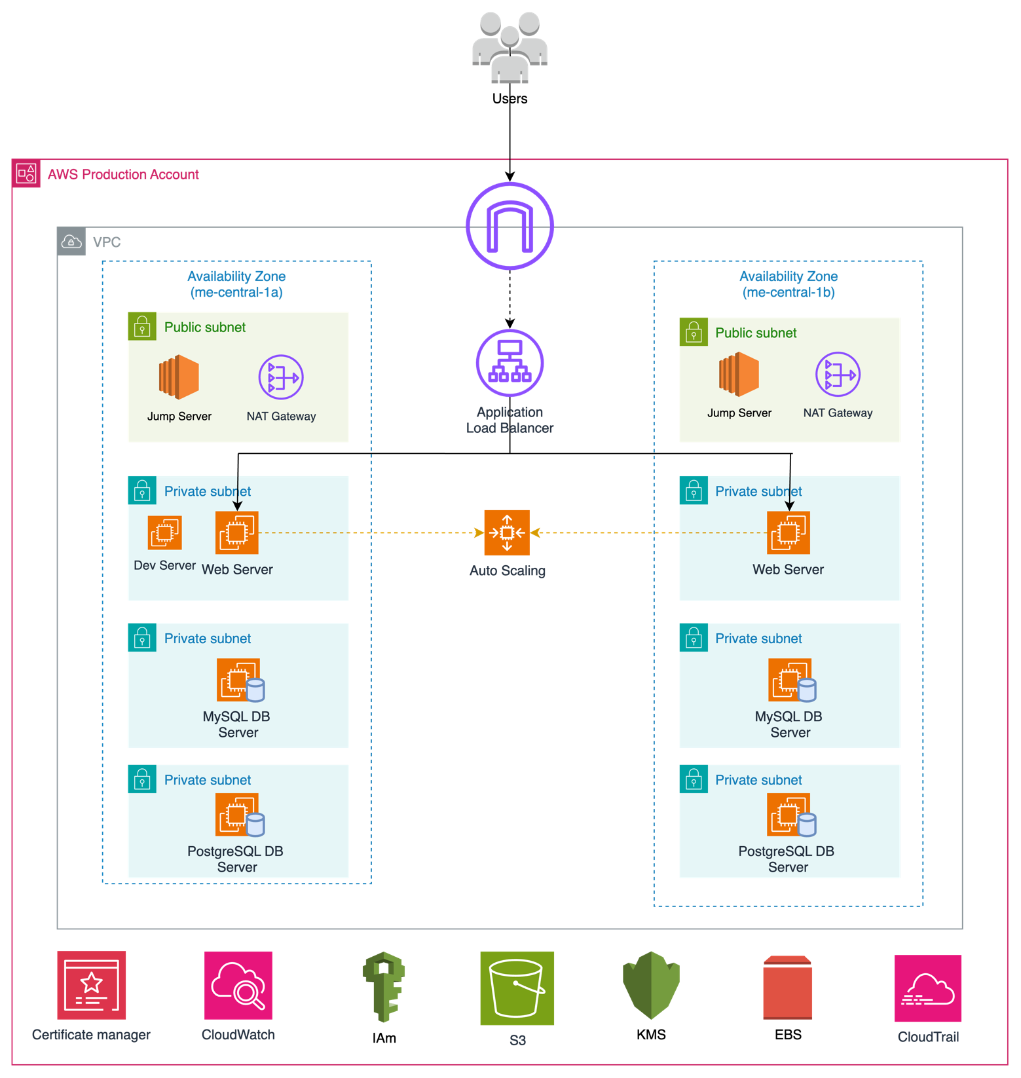

Figure 1: High Level LZ Design

The architecture for Najhum Technologies consists of a single AWS account with a Virtual Private Cloud (VPC) that spans two Availability Zones (AZs): me-central-1a and me-central-2b. Within this VPC, there are two public subnets and six private subnets, evenly distributed across the AZs. The public subnets house a jump server and NAT Gateways that facilitate outbound internet access for instances within the private subnets without exposing them to inbound traffic.
The private subnets are primarily dedicated to hosting the web server EC2 instances, which are configured with auto-scaling to manage varying traffic loads efficiently. These web servers are exposed to the internet via an Internet-Facing Application Load Balancer (ALB). The ALB distributes incoming web traffic to the web servers in the private subnets, ensuring load balancing and high availability.
Database instances, specifically MySQL and PostgreSQL, are also located in the private subnets, ensuring they are not directly accessible from the internet for enhanced security. These databases support the web servers by handling data storage and retrieval operations.
The architecture is further supported by several key AWS services. Identity and Access Management (IAM) controls user access to resources, while Key Management Service (KMS) provides encryption for data both at rest and in transit. Elastic Block Store (EBS) is used for storage attached to EC2 instances. SSL/TLS certificates for securing web applications will be managed by AWS Certificate Manager if required. Simple Storage Service (S3) is utilized for storing backups, logs, and static content.
Monitoring and auditing are handled by CloudWatch and CloudTrail, respectively. CloudWatch monitors the performance of AWS resources, collects and tracks metrics, and sets alarms for any anomalies. CloudTrail logs API calls and tracks changes to the infrastructure, providing governance and compliance support.

Traffic Flow
- External Traffic:
  - Users access the web application through the ALB.
  - ALB routes traffic to the appropriate web server EC2 instances in the private subnets.
- Administrative Access:
  - Administrators connect to the Jump Server in the public subnet.
  - From the Jump Server, administrators can SSH into EC2 instances in the private subnets.
- Database Access:
  - Web server EC2 instances connect to the MySQL and PostgreSQL databases in the private subnets for data storage and retrieval.

Low Level Design
The low-level design details the configuration and interactions of AWS resources. It specifies detailed networking configurations to ensure secure and efficient communication between components including tagging strategy and naming conventions to ensure consistency and ease of management.

Naming convention

Compute

Elastic Compute Cloud (EC2)
Resource | Format | Example
Instances | {identifier}-{env}-{type}-{count} | iotrics-webserver-prod-ec2-1
EBS volumes | {identifier}-{env}-{type}-{count} | iotrics-webserver-prod-ebs-1

Application Load Balancer
Resource | Format | Example
Function | {identifier}-{env}-{type} | iotrics-prod-lb

Networking

Virtual Private Cloud (VPC)
Resource | Format | Example
VPC | {identifier}-{env}-{type} | iotrics-prod-vpc
Subnet | {identifier}-{env}-{type}{count}-{zone} | iotrics-prod-subnet-public2-me-central-1a
Route Tables | {identifier}-{env}-{type}{count}-{zone} | iotrics-prod-rtb-private1-me-central-1b
Security Groups | {identifier}-{env}-{type} | iotrics-prod-sg

Storage

Simple Storage Service (S3)
Resource | Format | Example
S3 bucket | {identifier}-{env}-{type} | iotrics-prod-s3-app

Default Naming
Resource | Format | Example
Miscellaneous | {identifier}-{env}-{type} | iotrics-prod-db

Networking

The AWS worldwide infrastructure consists of regions and, within those regions, are availability zones. Najhum Technologies will be utilizing the below region and its given availability zones.
Region | Availability Zones
me-central-1 | me-central-1a
me-central-1 | me-central-1b

VPC
Amazon Virtual Private Cloud (Amazon VPC) enables you to launch Amazon Web Services resources into a virtual network you've defined. This virtual network resembles a traditional network that you'd operate in your own data centre, with the benefits of using the scalable infrastructure of AWS. All the entities of the Najhum Technologies would create their resources under a VPC of its own.
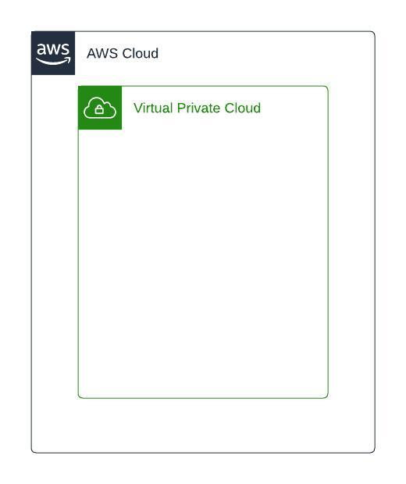

Private Subnet
Subnet is a logical segregation of VPC and is created under a VPC and private subnet is where any internal application which must be accessed within the VPC will be created. All the resources deployed within the private subnet will not be accessible from internet.
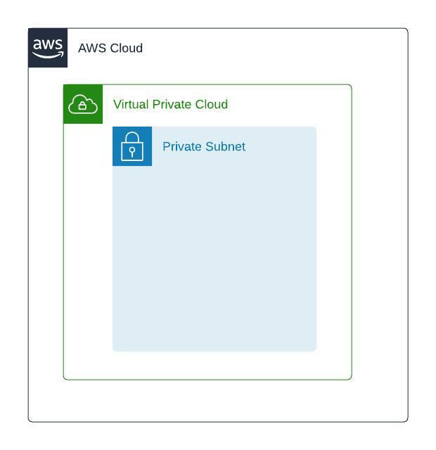

Internet Gateway
Internet gateway is a resource type in AWS which is used to provide internet access to the VPC and can be attached at a VPC level.
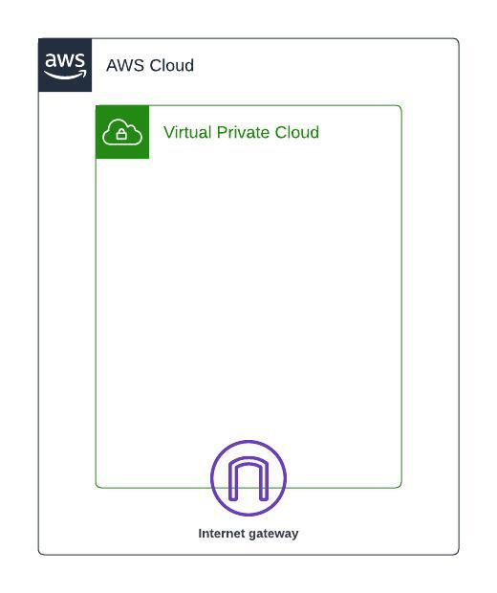

Public Subnet
A subnet can be created as a public if there is a route to internet via internet gateway. Any Internet facing application for Najhum Technologies will be deployed in the public subnet.
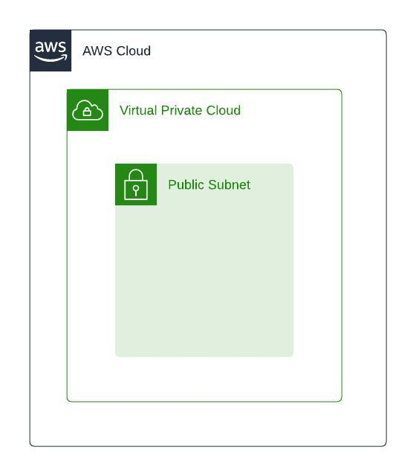

Availability zones
Availability Zones consist of one or more discrete data centers, each with redundant power, networking, and connectivity, and housed in separate facilities. These Availability Zones enable you to operate production applications and databases that are more highly available, fault tolerant, and scalable than possible when using a single data center. You can deploy your applications and databases across multiple Availability Zones. In the unlikely event of a failure of one Availability Zone, user requests are routed to your application instances in the second Availability Zone. This approach ensures that your application continues to always remain available.

Application in Najhum Technologies will be created in multi availability zones in Middle East (UAE) region.

Security Groups
Security groups are essential in AWS, acting as virtual firewalls to control inbound and outbound traffic for your resources. They provide critical protection by allowing you to specify precisely which traffic is permitted to enter and leave your instances, thereby enforcing strict access controls. By default, security groups deny all inbound traffic and allow all outbound traffic, which can be customized with rules to meet specific security requirements. This ensures that only authorized traffic can reach your application, mitigating potential security risks and safeguarding your data and services. Implementing well-configured security groups is fundamental to maintaining a secure and resilient AWS environment, especially during the Proof-of-Concept (PoC) phase, where security considerations are paramount.

Instances for Najhum Technologies will be attached to default security group and will be updated as per the application at application deployment stage.

NACL
Network Access Control Lists (NACLs) are a vital layer of security in AWS, providing stateless traffic filtering at the subnet level. NACLs allow you to control both inbound and outbound traffic for each subnet within your Virtual Private Cloud (VPC). Unlike security groups, NACLs are stateless, meaning return traffic must be explicitly allowed. This additional layer of security is crucial for setting granular network traffic rules, enabling you to allow or deny specific IP addresses, port ranges, and protocols. By implementing NACLs, you enhance the security posture of your AWS environment, ensuring that only authorized traffic flows to and from your subnets. It helps protect the infrastructure from unauthorized access and potential threats, providing a robust and secure foundation for evaluating your IoT application on AWS.

Subnets for Najhum Technologies will be attached to default NACL and will be updated as per the application at application deployment stage.

VPC Details
Below is the details of the VPC to be created in various AWS accounts:

Account Name | Account Number | VPC Name | VPC CIDR
Production | 938780652530 | iotrics-prod-vpc | 10.0.0.0/20

Subnets Details

Account | VPC Name | Subnet Name | Subnet Type | Subnet CIDR | AZ | Host  Count
Production | iotrics-prod-vpc | iotrics-prod-subnet-public1-me-central-1a | Public | 10.0.0.0/24 | A | 254
Production | iotrics-prod-vpc | iotrics-prod-subnet-public2-me-central-1b | Public | 10.0.1.0/24 | B | 254
Production | iotrics-prod-vpc | iotrics-prod-mysql-subnet-private1-me-central-2a | Private | 10.0.2.0/24 | A | 254
Production | iotrics-prod-vpc | iotrics-prod-webserver-subnet-private2-me-central-2b | Private | 10.0.3.0/24 | B | 254
Production | iotrics-prod-vpc | iotrics-prod-mysql-subnet-private3-me-central-2a | Private | 10.0.4.0/24 | A | 254
Production | iotrics-prod-vpc | iotrics-prod-mysql-subnet-private4-me-central-2b | Private | 10.0.5.0/24 | B | 254
Production | iotrics-prod-vpc | iotrics-prod-psql-subnet-private5-me-central-2a | Private | 10.0.6.0/24 | A | 254
Production | iotrics-prod-vpc | iotrics-prod-psql-subnet-private6-me-central-2b | Private | 10.0.7.0/24 | B | 254

Elastic Compute Cloud (Ec2)
Amazon Elastic Compute Cloud (EC2) is a foundational service in AWS, providing resizable compute capacity in the cloud. It allows you to run virtual servers, known as instances, that can be scaled up or down based on your application’s needs. EC2 offers a wide range of instance types optimized for different use cases, such as general-purpose, compute-optimized, memory-optimized, and storage-optimized instances, ensuring you can select the right type for your workload.
Key features of EC2 include:
- Scalability: EC2 instances can be easily scaled vertically or horizontally to handle increased load, making it ideal for applications that experience variable traffic patterns.
- Elasticity: With features like Auto Scaling, EC2 can automatically adjust the number of instances to maintain performance while minimizing costs.
- Flexibility: EC2 provides various purchasing options, including On-Demand Instances, Reserved Instances, and Spot Instances, allowing you to optimize cost and performance according to your budget and usage patterns.
- Integration: EC2 integrates seamlessly with other AWS services, such as Amazon S3 for storage, Amazon RDS for databases, and Amazon VPC for networking, creating a comprehensive and cohesive cloud environment.
- Security: EC2 instances can be secured using AWS Identity and Access Management (IAM) roles, security groups, and network access control lists (NACLs), ensuring that only authorized users and services can access your instances.
For Najhum Technologies, ec2 instances be used to host webservers and databases. These instances will be created as per below agreed configuration.
Role | OS | Instance Type | Subnet | vCPU | Memory  (GB) | EBS  vol gp3 (GB)
Dev/Test server | Ubuntu LTS | t3.xlarge | Private | 4 | 16 | 100
Web server 1 | Ubuntu LTS | c5.2xlarge | Private | 8 | 16 | 100
Web server 2 | Ubuntu LTS | c5.2xlarge | Private | 8 | 16 | 100
MySQL server 1 | Ubuntu LTS | c5.2xlarge | Private | 8 | 16 | 150
MySQL server 2 | Ubuntu LTS | c5.2xlarge | Private | 8 | 16 | 150
PostgreSQL server 1 | Ubuntu LTS | c5.2xlarge | Private | 8 | 16 | 150
PostgreSQL server 2 | Ubuntu LTS | c5.2xlarge | Private | 8 | 16 | 150
Production | Windows 10 | t3.xlarge | Public | 4 | 16 | 150

- All instances will have SSM and CloudWatch agent installed.
- EBS snapshot will be taken daily with 7 days retention.
- AWS managed default KMS Key will be used for EBS snapshot encryption.

Application Load Balancer (ALB)
The Application Load Balancer (ALB) is a key component of AWS’s Elastic Load Balancing service, designed to automatically distribute incoming application traffic across multiple targets, such as EC2 instances, containers, and IP addresses. ALB operates at the application layer (Layer 7) of the OSI model, allowing it to make intelligent routing decisions based on the content of the request.
Key features of ALB include:
- Content-Based Routing: ALB can route traffic based on request parameters such as the URL path, headers, HTTP methods, and query strings, ensuring that requests are directed to the appropriate targets.
- Load Distribution: By distributing incoming traffic evenly across multiple targets, ALB enhances the availability and reliability of your application, reducing the risk of overloading any single resource.
- Security: ALB supports SSL/TLS termination, allowing you to offload the decryption of incoming traffic to the load balancer, which simplifies certificate management and improves application performance. It also integrates with AWS WAF (Web Application Firewall) for additional protection against common web exploits and attacks.
- Health Checks: ALB continuously monitors the health of registered targets using customizable health checks, ensuring that only healthy targets receive traffic. This enhances the resilience and reliability of your application.
- Auto Scaling Integration: ALB works seamlessly with Auto Scaling to dynamically adjust the number of targets based on traffic demand, ensuring optimal performance and cost-efficiency.
- Flexible Target Management: ALB supports a variety of target types, including EC2 instances, ECS tasks, Lambda functions, and IP addresses, providing flexibility in how you architect your applications.
Rackspace will provision the ALB. However, the configuration will be provided by Najhum at deployment stage.

Simple Storage Service (s3)
Amazon Simple Storage Service (S3) is a highly scalable, reliable, and low-latency object storage service offered by AWS. It is designed to store and retrieve any amount of data, from anywhere on the web, making it ideal for a wide range of use cases, including data backup, archiving, content distribution, and big data analytics.
Key features of S3 include:
- Scalability and Performance: S3 is built to handle large volumes of data, scaling seamlessly as your storage needs grow. It provides high performance, ensuring quick access to your data.
- Durability and Availability: S3 is designed for 99.999999999% (11 9's) of data durability, storing data redundantly across multiple devices and facilities. It also offers configurable availability options to meet your specific requirements.
- Security: S3 offers robust security features, including encryption at rest and in transit, fine-grained access controls using AWS Identity and Access Management (IAM), bucket policies, and AWS Key Management Service (KMS) integration.
- Lifecycle Policies: S3 allows you to define lifecycle policies to automate the transition of objects to different storage classes (such as S3 Standard, S3 Standard-IA, S3 One Zone-IA, and S3 Glacier) and manage data retention.
- Data Management: S3 provides tools for data management, including versioning to retain multiple versions of an object, replication for cross-region redundancy, and tagging for organizing and managing resources.
- Integration: S3 integrates seamlessly with a broad range of AWS services, such as Amazon CloudFront for content delivery, AWS Lambda for serverless processing, and Amazon Athena for querying data directly in S3.
Najhum Technologies will use s3 for storing logs and other application dependencies with default encryption. Bucket configuration for application including lifecycle rules will be provided at the application deployment phase.

VPC endpoint will be enabled for s3 to establish private communication.

Tagging Strategy
Amazon Web Services allows assigning metadata to their AWS resources in the form of tags. Each tag is a simple label consisting of a customer-defined key and an optional value that can make it easier to manage, search for, and filter resources. Although there are no inherent types of tags, they enable Najhum to categorize resources by owner, environment, or other criteria.

General Best Practices:
- Always use a standardized, case-sensitive format for tags, and implement it consistently across all resource types.
- Consider tag dimensions that support the ability to manage resource access control, cost tracking, automation, and organization.
- Implement automated tools to help manage resource tags.
- Tags should be added to all resources (e.g., instances, volumes, databases, etc) that can be tagged.

Tagging strategy is a way to define and group your that are specific to your organization for standardization. We recommend Najhum to follow Rackspace standards for tagging resources:

Rackspace recommends following the Tagging Strategy below in each of the groups.

Tag Group | Tag | Value | Description
Business | Owner | Rackspace | Specifies the individual or team responsible for the resource. This could be an email address, a name, or a team identifier, aiding in identifying who to contact for issues or questions related to the resource.
Technical | Environment | prod | Describes the stage in the development lifecycle that the resource is part of, such as 'Development', 'Testing', 'Staging', or 'Production'. This helps in differentiating resources based on their deployment environment.
Technical | Name | <resource_name> | Provides a human-readable name for the resource, which can be used for easy identification. This is often set to a value that succinctly describes the resource, such as 'UserDatabase' as discussed in section 6.
Automation | Terraform | false | Indicates whether the resource was provisioned using Terraform. This can be a simple 'Managed by Terraform' note or a more detailed description, useful for infrastructure as code (IaC) management and identifying resources managed through code.
Cost | Cost Allocation | Iotrics-poc | This tag can be used to filter out the cost for deployed resources easily.

Logging and Monitoring

Introduction

Early-stage provisioning of logging processes and performance monitoring is recommended to ensure the long-term success of the Cloud project. AWS services provide wide-ranging monitoring and logging of the resources to grant awareness and visibility across the platform.

VPC Flow Logs
VPC Flow Logs provide detailed visibility into the IP traffic going to and from Virtual Private Cloud (VPC) network interfaces. They capture information about allowed and denied traffic, which can be used for monitoring, troubleshooting, and security analysis. By enabling VPC Flow Logs, you can gain insights into the traffic patterns and potential anomalies within the VPC. This is particularly useful for identifying unauthorized access attempts, analysing network performance, and ensuring compliance with internal and external security policies. VPC Flow Logs are invaluable for verifying the integrity and security application’s network traffic, helping to ensure that the system is functioning as expected and securely.

AWS CloudTrail
AWS CloudTrail is a service that provides comprehensive logging and monitoring of API calls made within the AWS account. It records actions taken by users, roles, and AWS services, providing a complete history of all account activity. CloudTrail logs are essential for auditing, compliance, and security, as they help you track changes to your infrastructure, detect suspicious activities, and understand the context of events. By enabling CloudTrail, we will ensure that every interaction with the AWS environment is documented, allowing for detailed analysis and forensic investigations. This is crucial as it provides transparency and accountability, ensuring that all actions are tracked and can be reviewed to maintain the security and integrity of the workload.

AWS CloudWatch
Amazon CloudWatch is a monitoring and management service that provides data and actionable insights for AWS, hybrid, and on-premises applications and infrastructure resources. It collects and tracks metrics, collects and monitors log files, and sets alarms to automatically react to changes in your AWS environment. CloudWatch enables us to gain real-time visibility into resource utilization, application performance, and operational health. By using CloudWatch, we can monitor the performance of the workload, track key metrics, and set up alerts for any critical events or thresholds. This ensures that any issues are promptly identified and addressed, maintaining the reliability and performance of your application. Additionally, CloudWatch logs can be used for troubleshooting and debugging, providing a comprehensive view of your system's behaviour.

Najhum Technologies will use VPC Flow Logs, CloudTrail and, CloudWatch for logging and monitoring with below retention period

Account Name | Service | Storage | Retention Period
Production | VPC Flow Logs | S3 | 30 days
Production | CloudTrail | S3 | 30 days
Production | CloudWatch | CloudWatch | 30 days

VPC endpoint will be enabled for CloudWatch to establish private communication.

Identity & Access Management
In managing access to resources and services within AWS, Identity and Access Management (IAM) serves as a cornerstone for security and governance. IAM enables organizations to control who can access AWS resources and what actions they can perform.

Najhum Technologies will utilize IAM's user, groups and roles for identity and access management. With IAM, we will define and manage user identities, assign permissions via policies, and control access to AWS services and resources. Roles within IAM allow for fine-grained access control, enabling users or services to assume specific permissions temporarily. By leveraging IAM, granular control over access permissions and can enforce security policies effectively across their AWS environments. All users will be MFA enabled.

Below are the identified groups and permissions to set up for Najhum

Account | IAM Group | Permission
Production | Admin | Full access
Production | Developer | Read and write to required services like EC2, S3
Production | Read-Only | View Access

Exclusions
(A) Installation & configuration of Customer or third-party applications
(B) Application functionality test
(C) Workload source code analysis
(D) Detailed design for individual applications
(E) Customer specific project management of internal organization dependencies
(F) Re-write and development of new application features.
(G) Backup, restore and DR management of data.
(H) Creation of additional resources/services in the AWS cloud environment
(I) Configuring of Security layers like WAF, GuardDuty, AWS Inspector, Security Hub, CloudTrail, AWS
Organization SCP, AWS Certificate Manager
(J) SSO Configuration with existing Identity Provider (Eg: AD, Azure, Okta)
(K) Integration with customers’ existing SIEM tools
(L) Bastion Host or Jump Server configuration and deployment.
(M) Configure VPN settings on the customer network gateway equipment.
(N) Migration of data or applications
(O) Creation of Customer end-user administrator documentation, training, or communication materials
(P) Architectural database changes
(Q) Any Engineering work required.
(R) Any work or charges not explicitly identified within SOW.

Note: Deployment of jump server and configuring CloudTrail is identified to be required after technical discussion and will be supported by Rackspace.

